Jalu Chaudhary

Class IT-314-DL1

Hands-On Assignments, Part I, for Chapter 2

1. Create a PL/SQL block containing the following variables: Assign your last name as the value of the text variable in the executable section of the block. Include statements in the block to display each variable’s value onscreen.

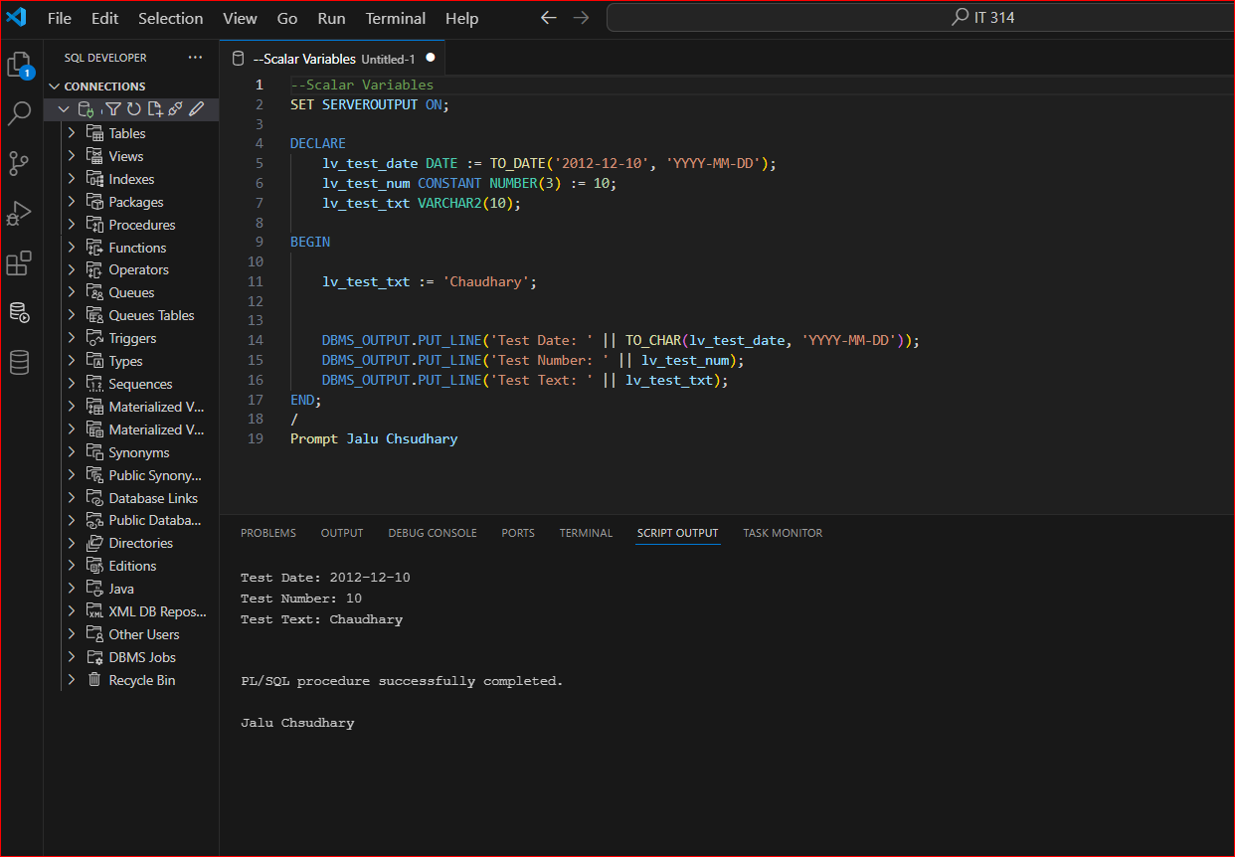

1. Assignment 2-2: Creating a Flowchart The Brewbean’s application needs a block that determines whether a customer is rated high, mid, or low based on his or her total purchases. The block needs to determine the rating and then display the results onscreen. The code rates the customer high if total purchases are greater than $200, mid if greater than $100, and low if $100 or lower. Develop a flowchart to outline the conditional processing steps needed for this block.

1. Assignment 2-3: Using IF Statements Create a block using an IF statement to perform the actions described in Assignment 2-2. Use a scalar variable for the total purchase amount, and initialize this variable to different values to test your block.

1. Assignment 2-4: Using CASE Statements Create a block using a CASE statement to perform the actions described in Assignment 2-2. Use a scalar variable for the total purchase amount, and initialize this variable to different values to test your block.

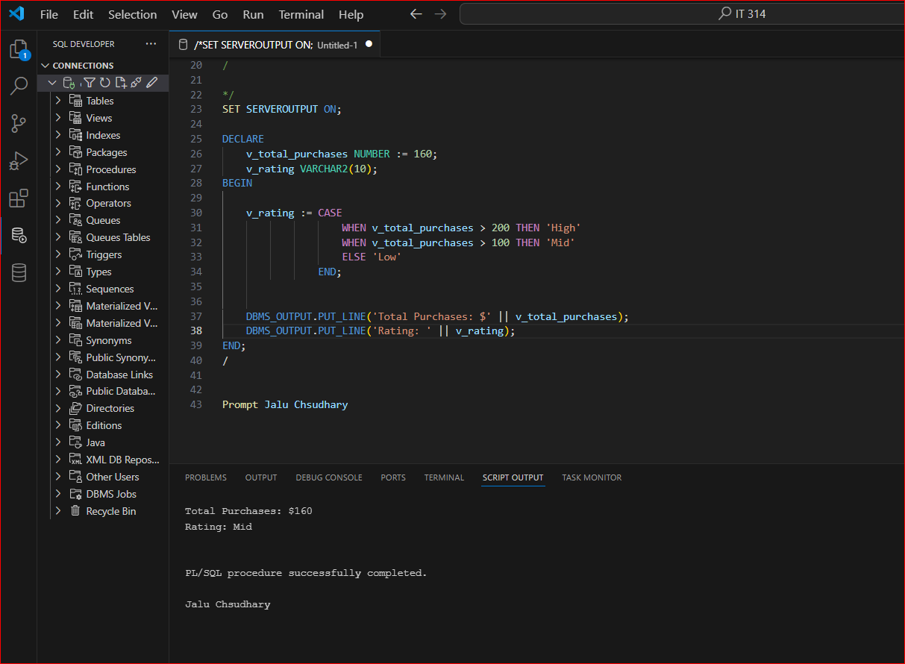

1. Assignment 2-5: Using a Boolean Variable Brewbean’s needs program code to indicate whether an amount is still due on an account when a payment is received. Create a PL/SQL block using a Boolean variable to indicate whether an amount is still due. Declare and initialize two variables to provide input for the account balance and the payment amount received. A TRUE Boolean value should indicate an amount is still owed, and a FALSE value should indicate the account is paid in full. Use output statements to confirm that the Boolean variable is working correctly.

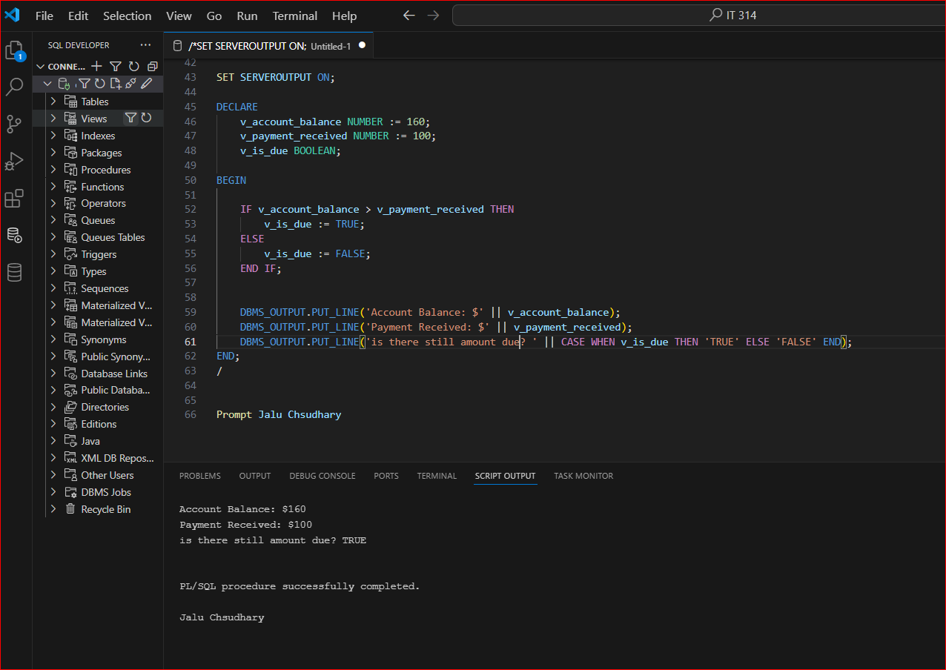

1. Assignment 2-6: Using Looping Statements Create a block using a loop that determines the number of items that can be purchased based on the item prices and the total available to spend. Include one initialized variable to represent the price and another to represent the total available to spend. (You could solve it with division, but you need to practice using loop structures.) The block should include statements to display the total number of items that can be purchased, and the total amount spent.

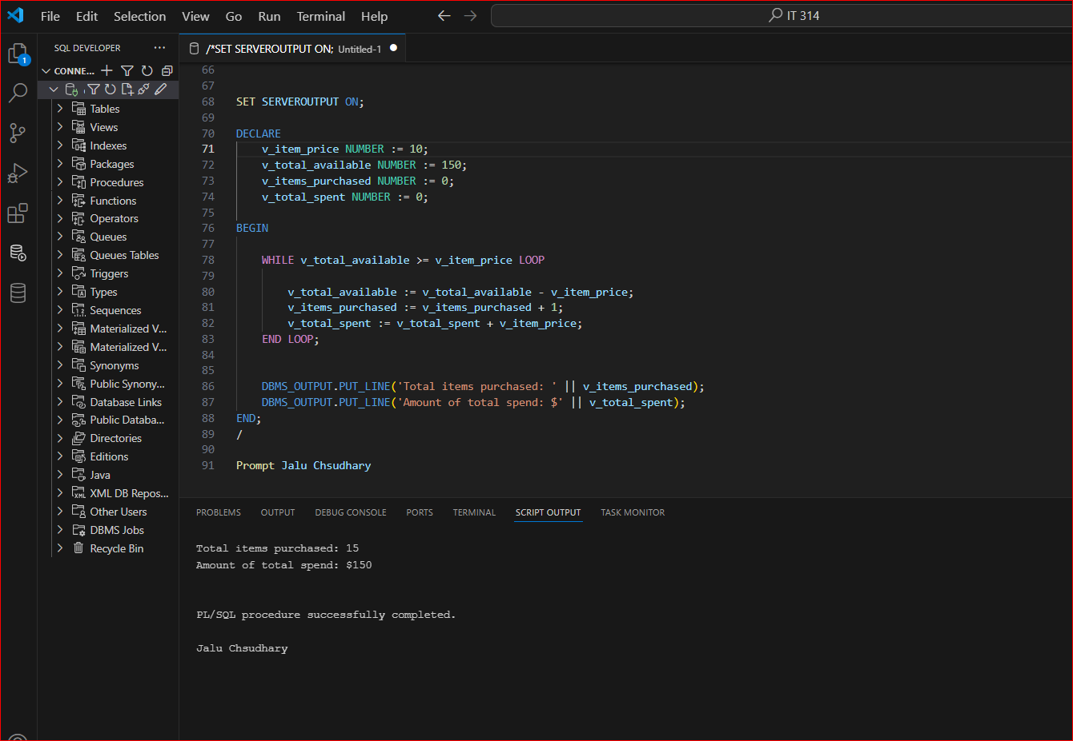

1. Assignment 2-7: Creating a Flowchart Brewbean’s determines shipping costs based on the number of items ordered and club membership status. The applicable rates are shown in the following chart. Develop a flowchart to outline the condition-processing steps needed to handle this calculation.

1. Assignment 2-8: Using IF Statements Create a block to accomplish the task outlined in Assignment 2-7. Include a variable containing a Y or N to indicate membership status and a variable to represent the number of items purchased. Test with a variety of values.

